**SPH3U 13.4 Electricity Generation**

1. **The AC generator**

|  |  |
| --- | --- |
| Design: |  |

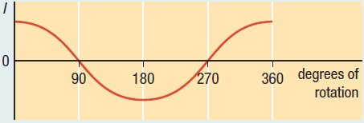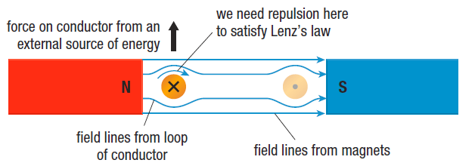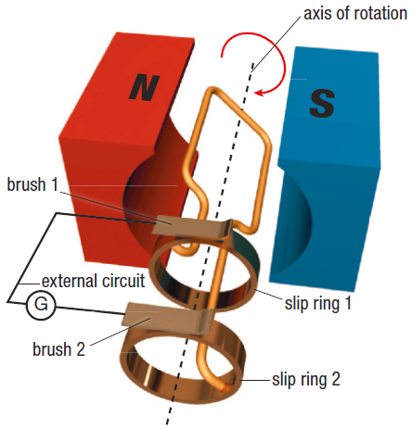

1. **The DC generator**

|  |  |
| --- | --- |
| Design: |  |

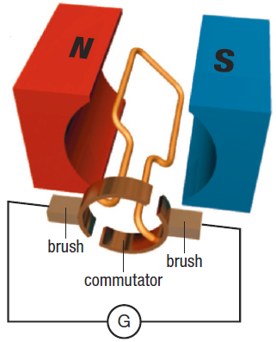

**Homework:** page 604: #2-4